Walnut Commons – An Intentional Community in Santa Cruz
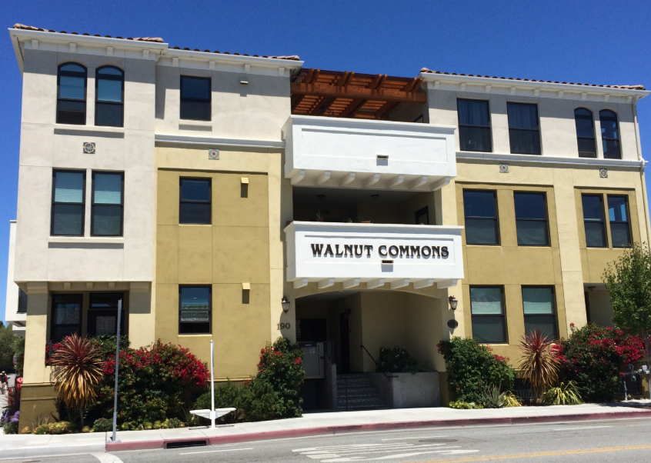

Our Vision
Walnut Commons is an urban community that fosters mutual support and cooperation while respecting privacy. We encourage ecologically responsible living, nonviolence, a healthy living environment, and we value active participation in the local and larger world.

